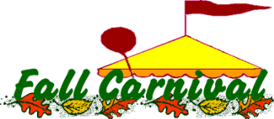
It’s Carnival Time!!!
Save the date, November 3rd from 3pm-6pm.
We have a great Carnival planned for you this year. We will have bounce houses, climbing wall, games, food & prizes. Kona Ice will be there to serve tasty frozen treats. Middle & High School Clubs will also be participating with their activities. High School students can earn volunteer hours at Carnival.
Fall Carnival is our main fundraiser of the school year. We are looking for donations for our Chance Drawing & Silent Auction Baskets. No donation is too small (or too big, once we had rain barrel water system donated) so please help us have some awesome baskets with your donations. If you know of businesses or restaurant you frequent, ask for a gift card or item donation. If you know a business who would like to sponsor a booth or game, send them our way. We love tickets, Gator Game, Theme Park, Theater, Movie, you name it, and we’ll take it! Do you have a Beach Condo to donate for a weekend? These are some of the items we’d love to have in our baskets this year.
At the October 12th PTO Meeting, we will have a Teacher’s Grant Applicant from the 2/3 Community. Please join us. We are child friendly and will be serving light refreshments.
Box Tops collections are going on NOW! The deadline to turn them in is Friday October 13th. Prizes will be Ice Cream for the winning advisory, T-shirts for the students with the most box tops in Elementary, Middle & High School! Each box top brings us 10 and last year we raised over $400!

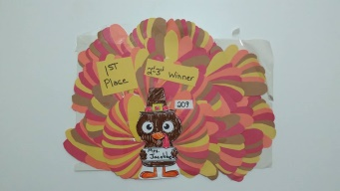
The 4th Annual Turkey Feather Contest will be from November 6th-9th. Money will be collected during Elementary lunch & feathers will be added to your Advisory Teacher’s Turkey. Feathers are .50 each. The winning Advisory will receive an Ice Cream party & the Teacher will get the Turkey Hat & a Turkey Sandwich! Last year your children raised over $900 for our Heart to Heart program. If you are able to help collect money & feathers during lunch, please contact Danica pkyptodanica@earthlink.net

The October Campus Connection is sponsored by
SHIPT.com use code PKY to save.
SHIPT your groceries, delivered.
